Project Design Phase
Solution Architecture
Date | 10 July 2026
Team ID | [Your Team ID]
Project Name | House Rent — Broker-Mediated Real Estate Platform
Maximum Marks | 4 Marks
Solution Architecture:
House Rent uses a classic 3-tier MERN architecture, with one addition that's central to the whole product: a broker approval gate sitting between property creation and public visibility, enforced in the API layer rather than left to the frontend.
Architecture Diagram:
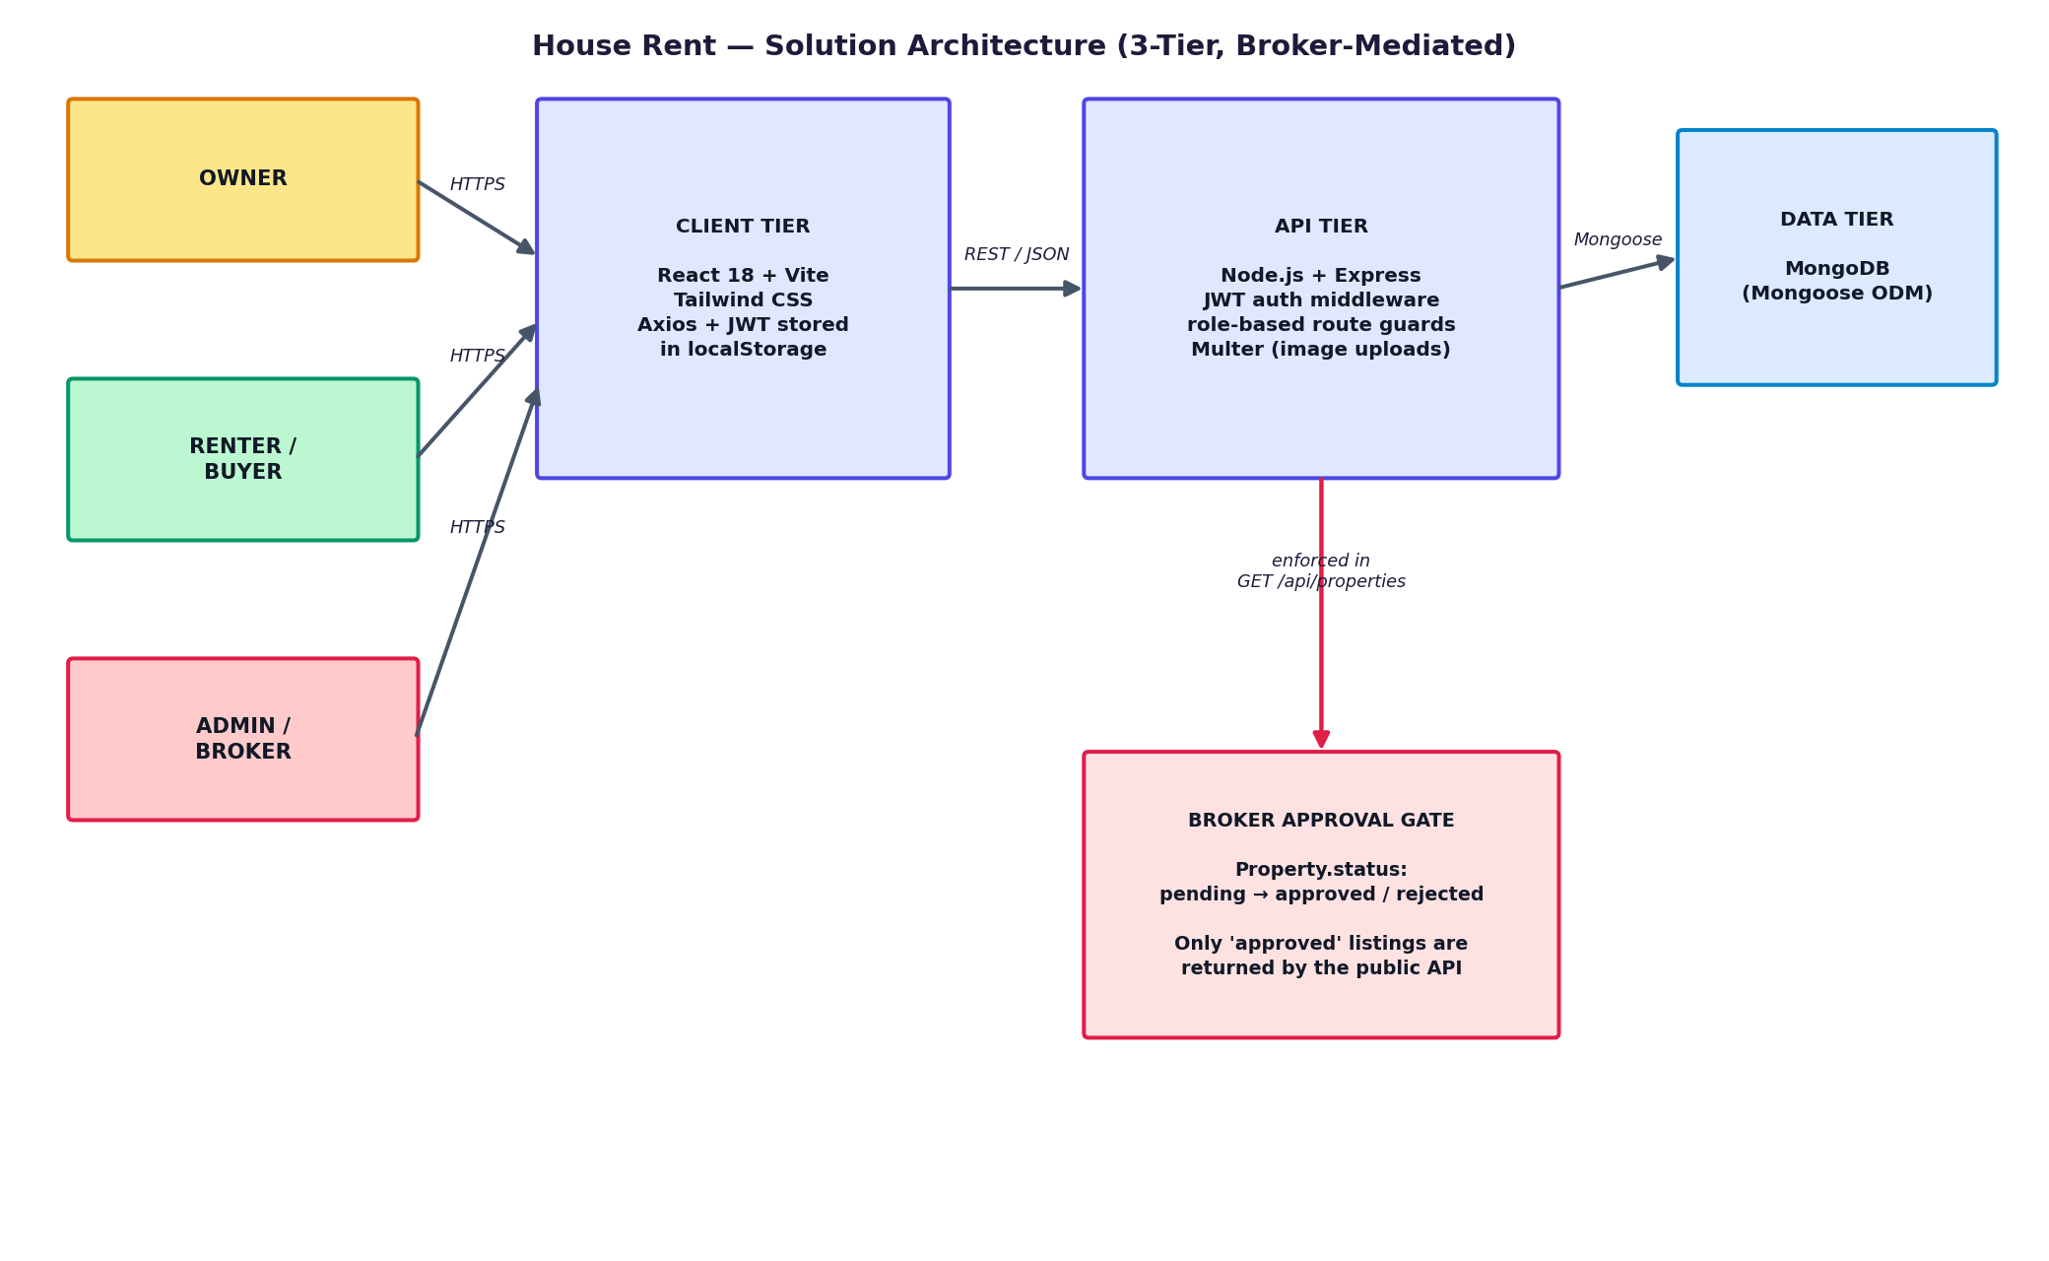
Figure 1: House Rent solution architecture (3-tier, broker-mediated)
Component Notes:
- Client tier — React 18 (Vite) SPA; Axios attaches the JWT from localStorage to every request; role-gated client-side routes (ProtectedRoute) mirror the server's own role checks
- API tier — Express REST API; requireAuth verifies the JWT, requireRole(...) gates each route by role; Multer handles property image uploads to disk, served statically
- Data tier — MongoDB via Mongoose; three core collections (Users, Properties, Bookings) linked by ObjectId references
- Broker approval gate — Property.status moves pending → approved/rejected only via an admin-only endpoint; the public listings endpoint and the booking-creation endpoint both filter/reject on this field, so the gate can't be bypassed by calling the API directly
Design Goals:
- Find the right technical solution to a trust/moderation problem, not just a listings CRUD app
- Keep authorization decisions server-side so the approval workflow can't be bypassed from the client
- Support a growing feature set (reviews, chat, notifications, map view) without re-architecting the core three tiers

